**EXPERIMENT NO. 1**

**Introduction to Linux and Windows Basic Networking Commands**

**Aim/Objective:** To understand the basic Windows and Linux based network commands.

**Requirements:**

1. Personal Computer with network interface card
2. Windows Operating System
3. Ubuntu Operating System

**Procedure for Windows based Network Commands:**

Students have to perform and understand following network commands as listed in the table-

1. Open the command prompt.
2. Change the **root directory** (C:\ or D\) using the command **cd..** before starting with the commands.
3. Implement each of the commands listed below with proper syntax.

| **Sr. No** | **Network Command** | **Description** |
| --- | --- | --- |
| 1 | ping | Verifies IP-level connectivity to another TCP/IP computer by sending Internet Control Message Protocol (ICMP) Echo Request messages. The receipt of corresponding Echo Reply messages are displayed, along with round-trip times. Ping is the primary TCP/IP command used to troubleshoot connectivity, reachability, and name resolution. If used without parameters, ping displays help.  **Example: c:\>ping google.com** |
| 2 | ipconfig | Displays all current TCP/IP network configuration values and refreshes Dynamic Host Configuration Protocol (DHCP) and Domain Name System (DNS) settings. If used without parameters, ipconfig displays your IP address, your router’s IP address, DNS server IP address, subnet mask, and default gateway for all adapters.  **Example: c:\>ipconfig** |
| 3 | ipconfig /all | Displays detailed information about all the adapters.  **Example: c:\>ipconfig/all** |
| 4 | hostname | Displays the host name portion of the full computer name.  **Example: c:\>hostname** |
| 5 | Tracert | Determines the path taken to a destination by sending Internet Control Message Protocol (ICMP) Echo Request messages to the destination with incrementally increasing Time to Live (TTL) field values. The path displayed is the list of near-side router interfaces of the routers in the path between a source host and a destination. The near-side interface is the interface of the router that is closest to the sending host in the path. If used without parameters, tracert displays help.  **Example: c:\>tracert google.com** |
| 6 | netstat | Display current TCP/IP network connections and protocol statistics. |
| 7 | pathping | Traces the route to target system and reports packet losses on each router in the route.  **Example: c:\>pathping google.com** |

The screenshots of the outputs need to be taken and complied in a Google doc file with proper observations for each network command.

**Procedure for Ubuntu based network Commands**

Open the Ubuntu network terminal and then use the following commands-

| **Sr. No** | **Network Command** | **Description** |
| --- | --- | --- |
| 1 | ping | Ping is a computer network tool used to test whether a particular host is reachable across an IP network. This is very basic and powerful tool to check Internet connection.  **Example: ping -c 4 google.com**  **Example: ping 10.10.10.10**  (-c option is used to pass how many packets you're sending) |
| 2 | clear | Clears the current screen of all the text |
| 3 | exit | Close the terminal window |
| 4 | ls | Lists the current directory. It’s like MS-DOS’s ‘Dir’ command |
| 5 | rm | Removes the files from the current directory |
| 6 | cd dir | Changes to the specified directory |
| 7 | cd - | Go back one step up towards root directory |
| 8 | pwd | Gives the host name. You can also use the host name command to give a new hostname to your system  **Example: sudo hostname temp.com** |
| 9 | mkdir | To make new directory or folder |
| 10 | mtr | It is a computer network tool used to determine the route taken by packets across an IP network.  It display the output as live updating as it does pinging of the hosts through the route.  **Example: mtr google.com** |
| 11 | netstat | This command display connection info, routing table information etc. To displays routing table information use option as -r.  **Example: netstat –r** |
| 12 | ifconfig  or  ip a  or  ip addr | **ip** command is used to display and manipulate routes and network interfaces. **ip** command is the newer version of**ifconfig.** ifconfig works in all the systems, but it is better to use ip command instead of ifconfig.  **Example: ip a** or **ip addr** |
| 13 | Tracepath | Traces the path of the network to the destination you have provided. It attempts to list the series of host through which your packets travel on their way to a given destination.  **Example: tracepath google.com** |

***Students need to execute the above commands, keep a copy of screen shots and note down the observations for each of the executed command.***

**Conclusion** *(to be written on Journal sheet)*: The network commands were implemented for both windows and Linux operating systems. *(Followed by your brief conclusion)*

**Post Experimental Exercise** *(to be written on Journal sheet)*

1. Explore and implement **any two** network commands of Windows and Linux system which are not listed in the laboratory write up and write conclusions about them.

*(Hint: Try commands, getmac, arp, arp -a in windows and ip a, route –n in ubuntu)*

1. Answer following questions,
   1. What is the full form of ICMP? Find which layer protocol is this?
   2. What is TTL? Explain how is it used?
   3. What is the full form of DHCP? Find which layer protocol is this?
   4. What is the IP address of your PC?=192.168.3.119
   5. What is the MAC address of your PC?=C8-7F-54-16-B9-27

RIYA SANDIP INDAP,44

~ping

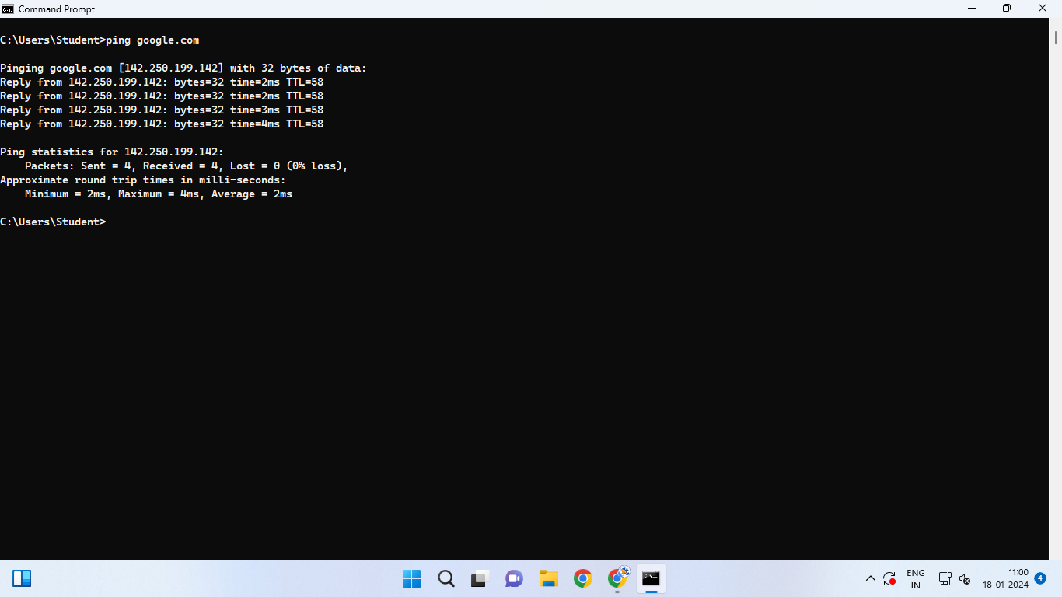

ping command used 32 bytes of data,used 4 packets which were sent and received and 0 packets where lost/.

~ipconfig

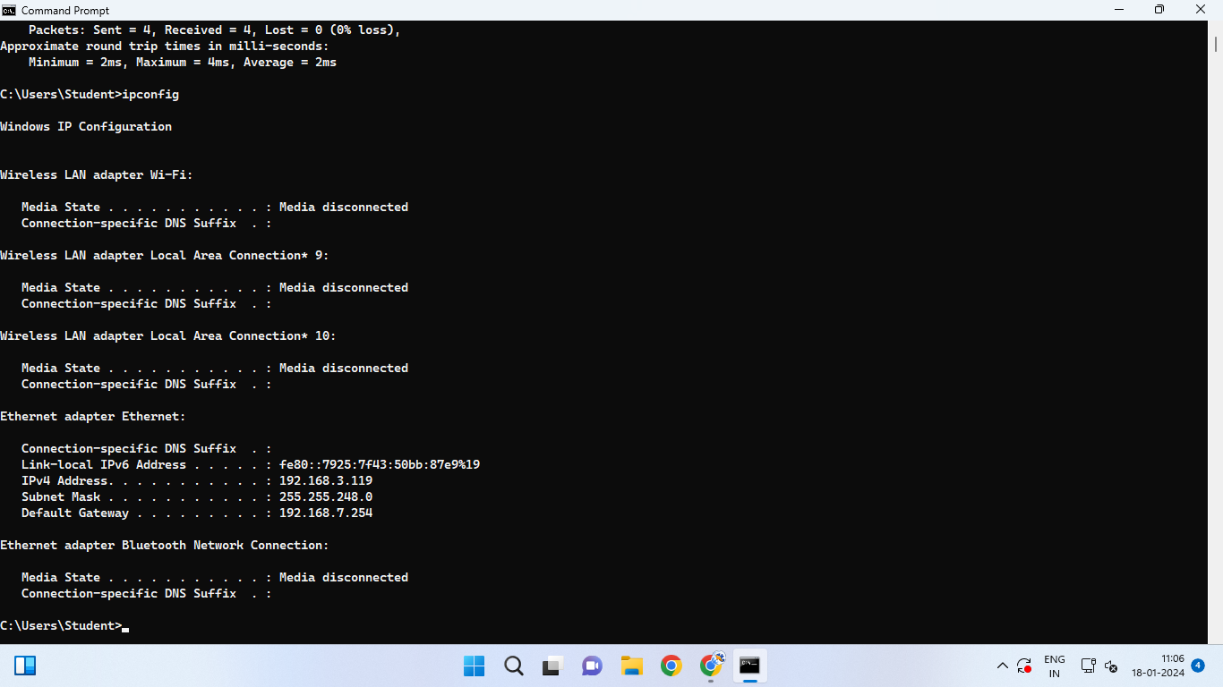

ipconfig command without parameter is displaying my ip-address(192.168.3.119),my router’s ip-address,my subnet mask(255.255.248.0) and default gateway(192.168.7.254).

~ipconfig/all

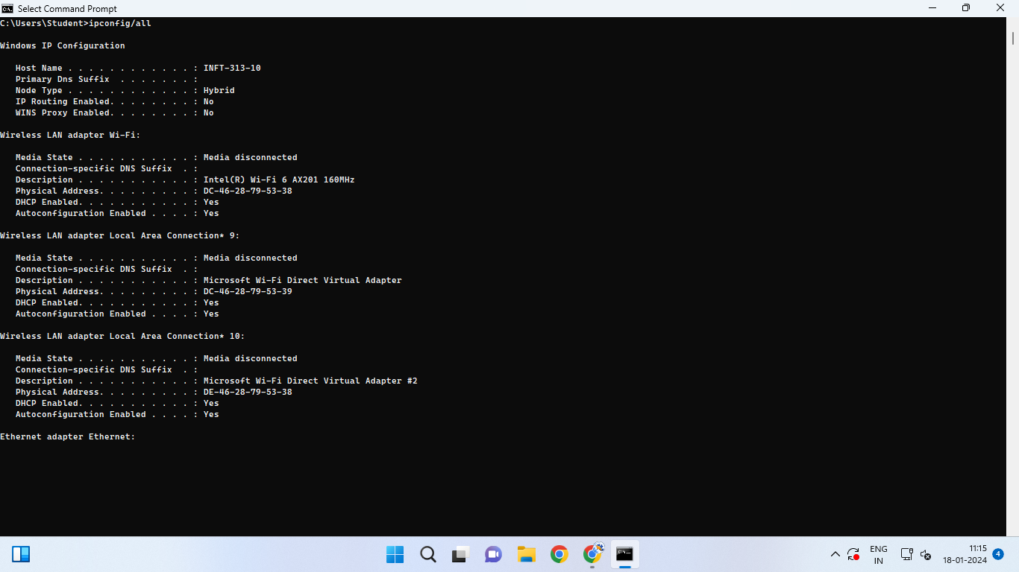

ipconfig/all command is giving detailed description of all the adapters connected to pc.here it is showing adapters connected to host INFT-313-10.

~hostname

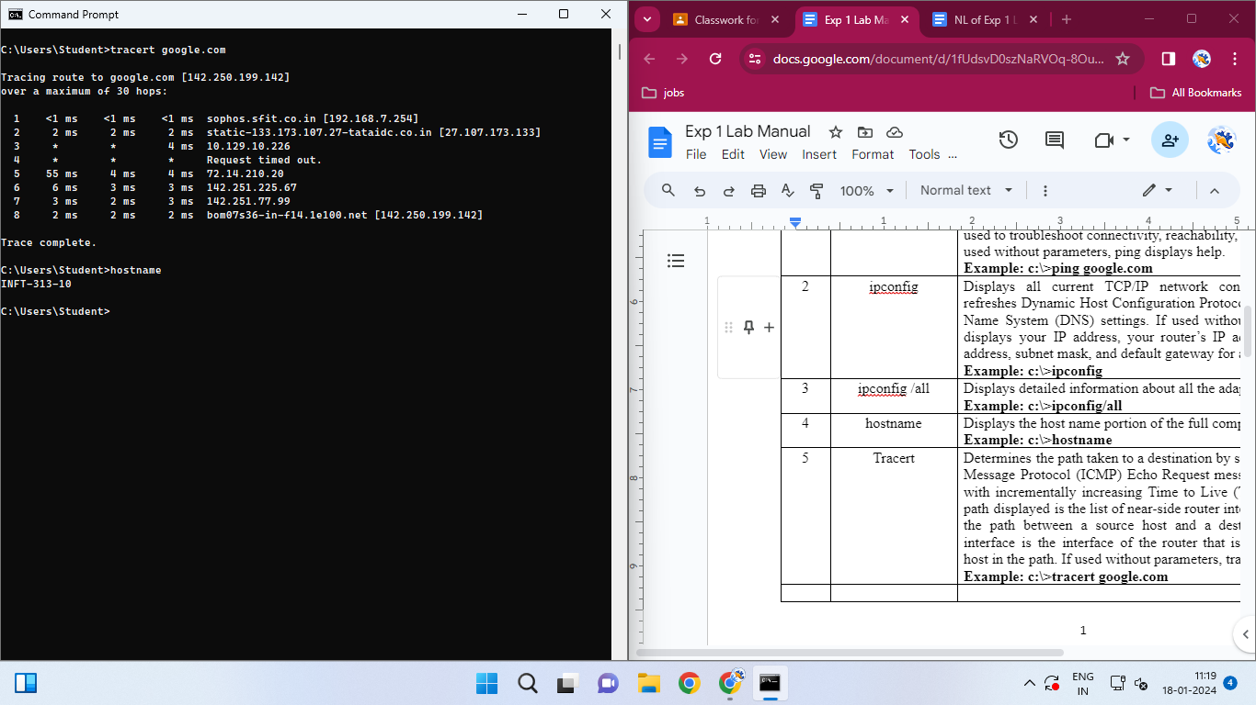

hostname command displays the hostname of the computer.here the host is INFT-313-10.

~tracert

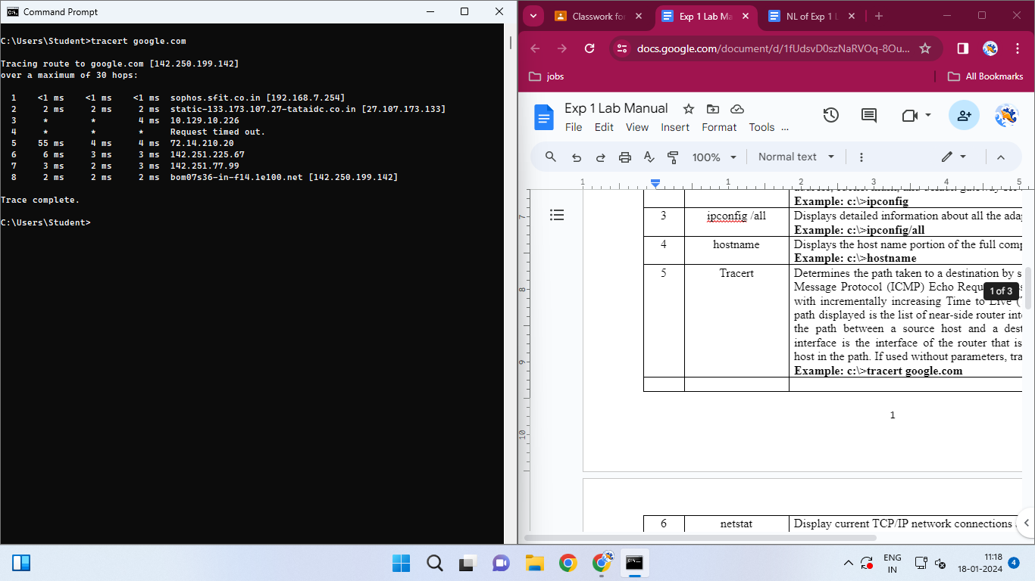

tracert command is displaying the route taken to the destination google.com. The routers in the path to the destination are ‘sophos’ and ‘tataidc’.

~netstat

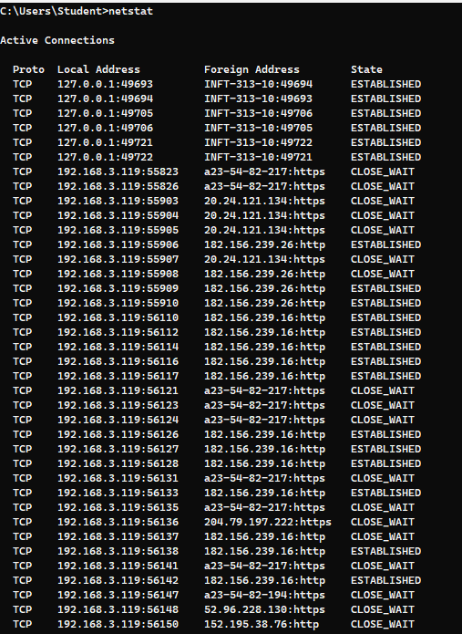

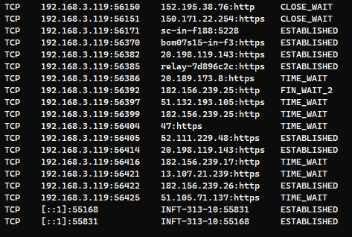

netstat command is displaying all the TCP/IP network connections and protocol statistics.

~pathping

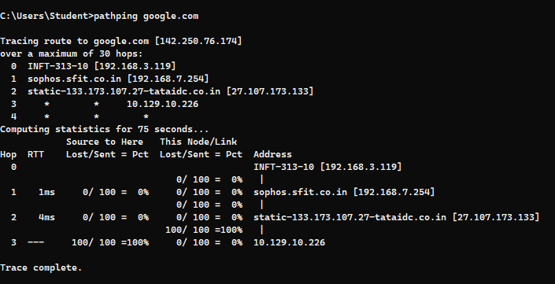

pathping command is telling about the packets lost at each router.0 packets are lost at sophos router.0 packets are lost at tataidc router.

**post-exp**

~getmac

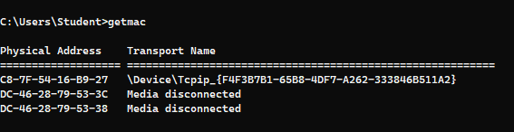

the MAC address of Tcpip adapter is C8-7F-54-16-B9-27.

~arp -a

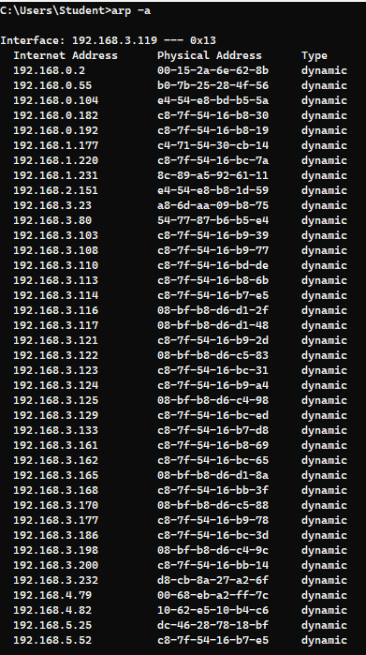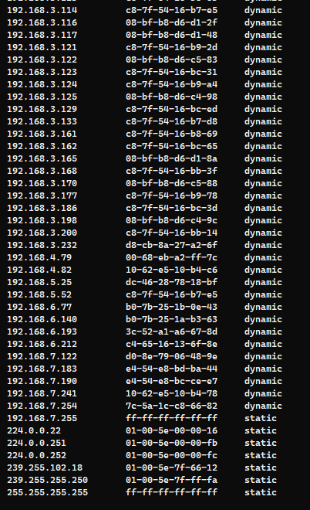

**ubuntu**

~ping

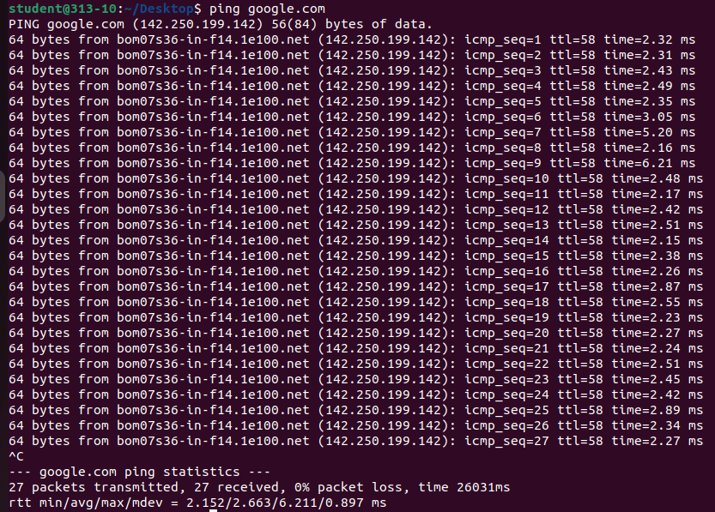

The ping command here has sent 27 packets,has received 27 packets in 26031miliseconds.

~rmdir/mkdir/ls

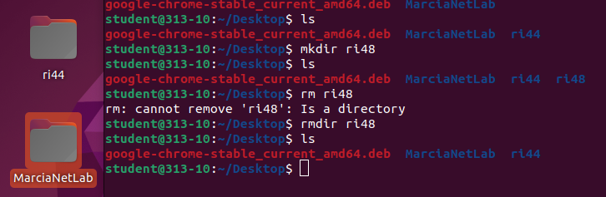

we created directory ri48 using mkdir command.we listed the current directories using ls command(‘ri48’,’ri44’).we removed ri48 using rmdir ri48 command.and then again listed the directories using ls command.

~mtr

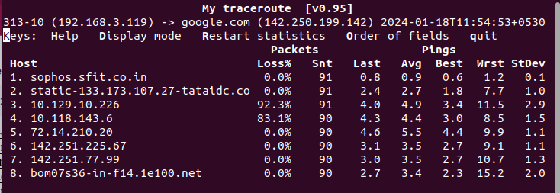

the route taken by the packets across the IP network is through the routers sophos and tataidc.

~netstat -r

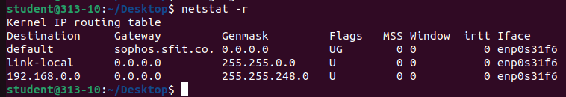

the default gateway in this Kernel IP routing table is sophos.

~ifconfig

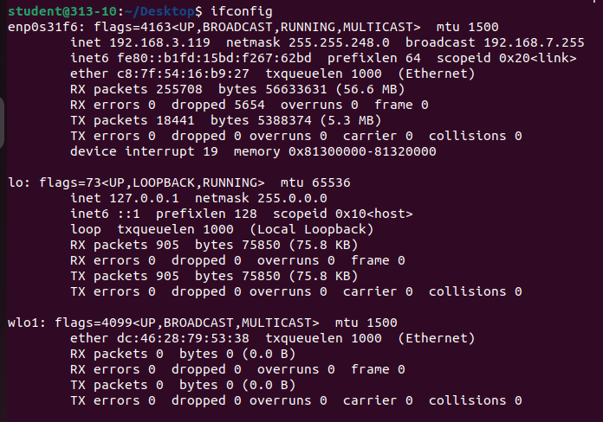

this command is displaying and manipulating routes and network interfaces.

~tracepath

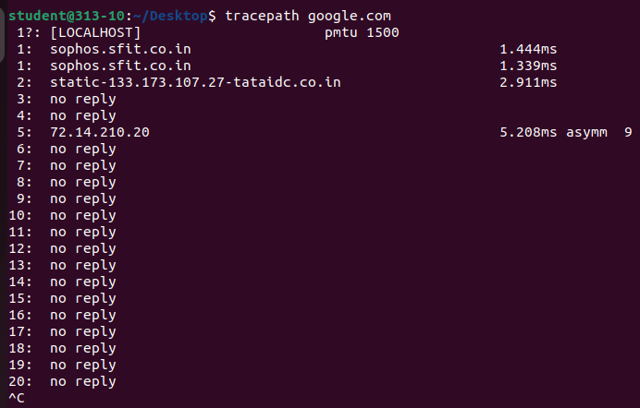

tracepath is listing the host through which packets are traveling on the way to destination google.com.

the host here are sophos and tataidc.

~ip a

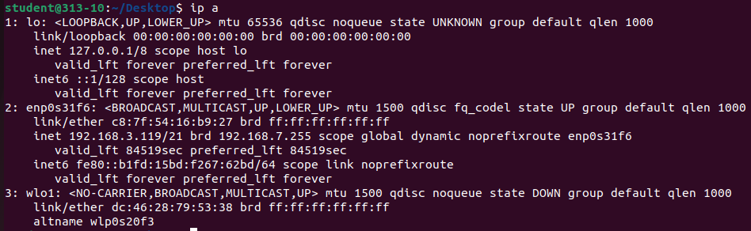

this command is displaying and manipulating routes and network interfaces.this command is the newer version of of ifconfig

~route -n

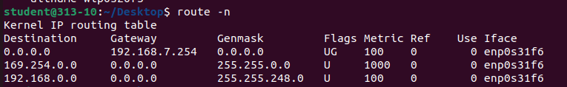

the destination gateway in this Kernel IP routing table is IP address-192.168.7.254.